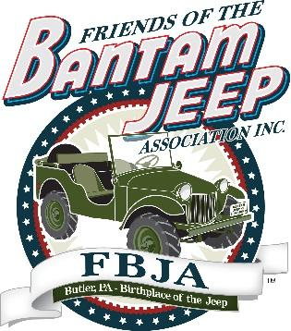
FOR IMMEDIATE RELEASE
Friends of the Bantam Jeep Association to Offer Financial Gifts to Butler County 501C3 Non-Profit Organizations
Application Deadline is October 31st, 2023

BUTLER COUNTY, PA (September 11, 2023) – For the seventh year, the Friends of the Bantam Jeep Association, Inc. (FBJA) will award financial gifts to Butler County 501c3 non-profit organizations. The program has awarded more than $140,150 to organizations in the community since 2016. In total, FBJA has given away $272,567 in financial gifts and donations to non-profit partners since then.
“FBJA is making a difference in Butler County,” said Todd Wagner, FBJA president. “Our two annual events support businesses in the County, and our financial gifts program makes a difference for many non-profit organizations and the people they serve.”
Application Requirements and How To Apply:
- Butler County 501c3 non-profit organizations must apply online. The online application, available at http://www.bantamjeepfestival.com/financial-gift-application, must be received no later than October 31st at 5 p.m. The application link is also available at the top of the Festival’s website home page, www.bantamjeepfestival.com.
- In the application, organizations must explain in 500 words or less how they benefit the community and how any potential funds received will be used.
- Applicants must provide proof of non-profit 501c3 status.
(more)

- After gifts are awarded, the recipients will be expected to provide an update on their projects’ progress and/or completion and provide photos to demonstrate the gifts’ impact on their organization.
“The Friends of the Bantam Jeep Association’s Board of Directors will review the applications in November and determine which projects and organizations we wish to support this year,” said Wagner. “Gifts will be distributed based on need and how the gift benefits the community.”

Festival Supports Even More Local Groups
In addition, the Association has already provided $22,197 to other local organizations that helped execute the 2023 Festival. More than $160,000 has been given to involved organizations since 2016.
The 2023 organizations include Butler JROTC, Butler Masonic Lodge #272, Butler Outdoor Club, CANDLE, Inc., CB Rangers, Civil Air Patrol, East Coast 4 Wheel Drive Association, Heritage Region Jeep Alliance, the Knights of Columbus, Mon Valley Jeep Club, Oil Valley Jeeps, PA Volunteers, Rodfathers of Butler, Saxonburg Area Rotary Club, Slippery Rock Twp. VFD, Wilds Jeepers, and the Zelienople American Legion Women’s Auxiliary.
The Friends of the Bantam Jeep Association was formed in October 2015. It is comprised of more than 80 volunteers who work together to plan and execute the successful Bantam Jeep Heritage Festival which attracts nearly 3,000 Jeeps to Butler County each June to celebrate Butler’s notoriety as the birthplace of the Jeep. FBJA also executes Bantam TrailFest, a smaller event held in October.
# # #

Media Contact:
Patti Jo Lambert
724-561-4188
lambertpj@bantam.org

